Tullibigeal Central School

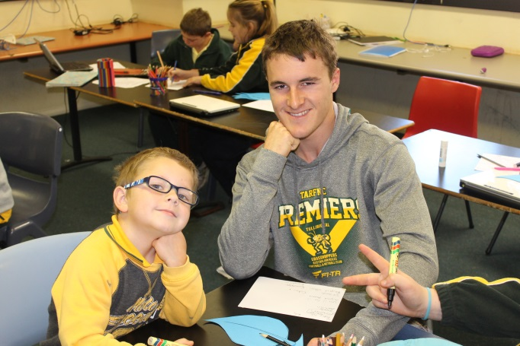

School vision statement |  | School context |  | School planning process
Tullibigeal Central School supports the local community and develops lifelong learners who are engaged with their town and who exhibit skills as 21st century learners.  The school aims to address the learning needs of all students and to provide opportunities for children to participate in a range of enrichment opportunities to broaden their options post-school. |  | Tullibigeal Central School is a small, committed, inclusive school which demonstrates flexibility and practices to modify curriculum to engage all learners. Our school caters for the learning needs of some students who have encountered obstacles in other contexts |  | Community consultation and staff and community development was undertaken in 2014.  School Development of the plan was ongoing in 2015.  Staff and P and C have again been involved in refining our milestones and tweaking our direction in 2016.

STRATEGIC DIRECTION 3
Engagement - developing engaged lifelong learners, leaders and problem solvers

STRATEGIC DIRECTION 2
Relationships –
fostering positive partnerships within the school and with the local and wider community

STRATEGIC DIRECTION 1
Professionalism –
building committed and resilient learners through enhanced teaching, organisation and welfare practices within the school.

Purpose:  Developing the school's pedagogical, welfare and organisational practices to build a community of committed and resilient learners. |  | Purpose:  Build a culture of genuine partnership to ensure school and community devotion to the development, opportunities and safety of every student |  | Purpose:  Engage self-directed and self-confident learners who can enjoy a variety of post school options.

Strategic Direction 1:
Professionalism - Building committed and engaged learners through enhanced teaching, organisational and welfare practices within the school.

Purpose |  | People |  | Processes |  | Products and Practices
Developing the school's pedagogical, organisational and welfare practices to build a community of committed and engaged learners |  | How do we develop the capabilities of our people to bring about transformation?  Students: Appreciate that high expectations about behaviour and application are part of their best interests  Staff: Project their own professionalism. Staff use data to understand the learning needs of students to plan learning opportunities and facilitate students plans as learners.  Parents/Carers: Are encouraged to feel that the school is approachable and committed to their child’s growth. They play an active role in their child’s PLP each semester  Leaders: Model professional conduct. Make adjustments to the curriculum offerings of the school to better meet the learning needs of each child |  | How do we do it and how will we know?  - High Expectations- of school organisation, teacher professionalism and student engagement  - Focus on the learning needs of the students; literacy, numeracy, engagement  - Engage with the data regarding student learning  Evaluation Plan  Gauge the completeness of PDPs and the extent to which staff have engaged with this process. |  | What is achieved and how do we measure?  Product  - Professional Development Plans developed for each staff member and include professional learning goals for themselves through the year. Buddy system builds reflection on practice.  Product:  - Policies published in the newsletter and the school’s website.  Product:  - Programs in line with NSW’s response to the National Curriculum are developed and implemented within the school according to the published timelines.  What are our newly embedded practices  Practice  - High expectations of student engagement and commitment are demonstrated by each staff member’s planning and practices in the classroom  Practice:  - BOS warning letters and other written communications are used as a method of conveying high expectations to students.  Practice  - Classroom visits by supervisors/colleagues evaluate the success of planning.
Improvement Measures
- PLPs for staff foster climate of discussion around and reflection on practice
- Policies reviewed and housed in Sentral
- TTFM responses reflect teachers’ improving use of data to inform teaching
- Respectful and Inclusive is reflected in teacher’s PDPs

Strategic Direction 2: Relationships - fostering positive partnerships within the school and with the local and wider community
Purpose |  | People |  | Processes |  | Products and Practices
Why do we need this particular strategic direction and why is it important?  Developing genuine partnership to ensure school and community devotion to the development, opportunities and safety of every student |  | How do we develop the capabilities of our people to bring about transformation?  Students: Develop resilience to be able to engage with their own achievements and plan goals for themselves.  Staff: Staff are encouraged to focus on their relationship with each student.  Staff are engaged in and develop skills with; interviewing students, assessing their position on the continua, listening to and helping students make plans they believe in.  Parents/Carers: Get a better idea about how to interpret assessment information. Help their child manage the responsibility for planning their learning.  Community Partners: Value the work of the school. Contribute expertise  Leaders: Continue to espouse the value of partnerships. Show respect for a range of values. |  | How do we do it and how will we know?  - Develop a Personalised Learning Plan for every student. This plan is developed in conversation with each student and their parents, together with the school.  - Building on and fostering learning partnerships; F1, Aspire Paths, cattle show…  - Develop C21 web presence and use social media to better communicate on behalf of the school and its stakeholders/community.  Evaluation Plan  PLPs will be required for every student by the end of term 1 2016  School and community valuing of partnership initiatives  Improved webpage, availability of resources for student learning  Students as the creators of product; assignments; learning materials |  | What is achieved and how do we measure?  Product  - All students have a Personalised Learning Plan  - Improved school communication through social media as well as through the newsletter. The school models a sophisticated approach to its cyber-presence and encourages cyber safety and cyber citizenship among our students  What are our newly embedded practices and how are they integrated and in sync with our purpose?  Practice:  - Students are encouraged to produce imaginative pieces to be assessed which helps develop teamwork and creativity.  - Stronger sense of partnership between the child, their parents and the school  - Development of intellectual capacity, imagination and inventiveness, spirit and joy.
Improvement Measures
- Personalised Learning Plans for every student, negotiated between the school, student, parents
- TTFM responses value improvements to Web presence, communication and partnership

Strategic Direction 3: - Engagement - Creating engaged lifelong learners and problem solvers

Purpose |  | People |  | Processes |  | Products and Practices
Why do we need this particular strategic direction and why is it important?  Develop self-directed and self-confident students who can lead their community in the future. |  | How do we develop the capabilities of our people to bring about transformation?  Students: Take on the PBL messages and have happier and more effective time at school. Be active learners by planning each semester’s learning and its evaluation.  Staff: Support and teach the positive behaviour for learning messages. Put significant effort into knowing the achievements of each student and facilitating their planning of their learning for the next semester.  Parents/Carers: Parents value and encourage their child’s achievements and positive values.  Community Partners Support and endorse the behaviour for learning messages. Support the processes which are designed to give students greater ownership of their learning.  Leaders: Model being a lifelong learner. Convey the message that we have a growth mindset regarding what students can do and achieve. |  | How do we do it and how will we know?  - Implement structures which encourage engagement such as Positive Behaviour for Learning with special emphasis on resilience.  - Structures which engage each student in planning and evaluating their own learning  Evaluation Plan  Positive Behaviour for Learning launch and signage will have been completed.  Student learning of the PBL messages and application of these to their lives at school.  Student involvement in evaluating their success and planning their efforts as learners. |  | What is achieved and how do we measure?  - Students are encouraged to manage their own behaviour and evaluate it with respect to their own learning and the learning of their peers.  Product:  - Part of each report contains the student’s own reflection on their progress towards their learning goals and their plans to develop next semester.  Product:  - Every student has an Personalised Learning Plan which is negotiated between the student, their carers and the school  What are our newly embedded practices and how are they integrated and in sync with our purpose?  Practice:  - Secondary as well as primary teachers teach reading for meaning to their students in class time.  Practice:  - Curriculum is regularly evaluated and adjusted; innovative practices to cater for student engagement are actively sought and catered for.
Improvement Measures
- Produce information on Naplan and placement on learning continua to measure student improvement which should average about a band per year.
- TTFM responses require reflection on students valuing of Learning Planning Meetings.

